47th ANNUAL TRADE EXPO - MARCH 8th 10AM
FACEBOOK LIVE – POWER PANELS
Presenter Bios

AMERICAN HOTEL & LODGING ASSOCIATION – CHIP ROGERS

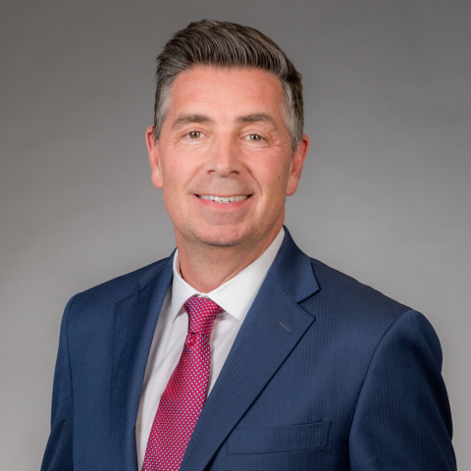

Chip Rogers joined the American Hotel & Lodging Association (AHLA) as President and CEO in January 2019. AHLA is America’s only national association dedicated to serving the interests of the entire hotel and lodging industry.
In his role as President & CEO, Chip has led the AHLA team and the lodging industry to achieve tangible results. Subsequently, he has received numerous awards and recognitions including Business Travel News “25 Most Influential 2020”, “Top Lobbyist in 2019 and 2020” by The Hill, “Small Business Defender of the Year” by Job Creators Network, and “Most Influential People in Washington” by Washingtonian Magazine.
Under Chip’s leadership, AHLA was named as “100 Associations That Will Save the World” by ASAE, was honored with the White House “Presidential Award for its Pledge to America’s Workers” and was recognized with the PR Week Purpose Awards 2020.
In addition to leading AHLA, Chip is a member of the board of directors for the United States Travel Association, Community Leaders of America, and the California Hotel & Lodging Association. Prior to joining the hospitality industry, Chip served in the Georgia General Assembly. He was elected to office six times and was unanimously elected twice to serve as Senate majority leader.
Chip earned his undergraduate degree from Georgia Tech and his MBA from Georgia State.

DE HOTEL & LODGING ASSOCIATION - VINCE DIFONZO, CHA

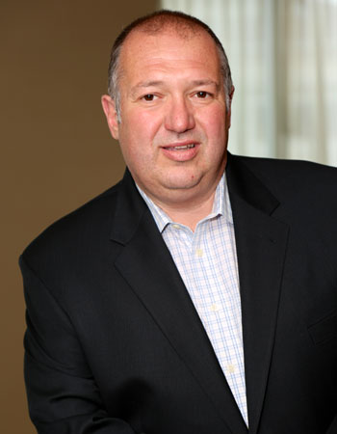
Vince DiFonzo is a partner of TKo Hospitality and serves as the President. Prior to TKo, Vince worked with Meyer Jabara Hotels for 23 years and most recently served as Vice President of Operations. Vince began his hospitality career with Servico, Inc. where he was the first Management Development Trainee and eventually grew to become General Manager at the Hilton Head Inn Resort in Hilton Head Island. He later joined Concord Hospitality to become VP of Food and Beverage. During his tenure with Concord, Vince led the efforts of re-positioning several new restaurants, catering facilities and nightclubs.

Vince is an accomplished leader and has extensive experience in operations, sales and marketing, union negotiations, property acquisitions, new hotel openings, brand relationships and third-party management. He is known as a passionate and creative executive with a focus on people development. He also has been recognized with prestigious awards both by his employers as well as the industry for his operational performance as well as his leadership practices. Some of his recognitions include multiple General Manager of the Year awards, a Mirror of MJ Hotels, Marriott, Hilton and IHG Brand performance awards, “Best Place to Work” in DE and Business Person of the Year.

Vince graduated Magna Cum Laude from West Virginia University with Bachelor of Science degree in Business Administration. Today he still values learning by partnering with area universities as a guest lecturer as well as receiving his Certified Hotel Administrator (CHA) and his Certified Food and Beverage Executive (CFBE) designations.

Service is not just a word Vince uses in coaching hotel associates…he has been actively involved in a number of national, community and industry organizations serving as Board of Director for American Hotel and Lodging Association, Hyatt’s Brand Advisory Board, Chairman of the Delaware Hotel and Lodging Association, Boards of Directors of the Maryland Hotel and Lodging Association, the Greater Wilmington Convention and Visitors Bureau, DE State Tourism Advisory Board, New Castle County Chamber of Commerce, Rehoboth/Dewey Beach Chamber of Commerce, Southern DE Tourism, Dewey Beach Business Partnership, Christiana Rotary Club, Society da Vinci and Delta Outreach and Education Center.

MD HOTEL & LODGING ASSOCIATION - BEN SEIDEL

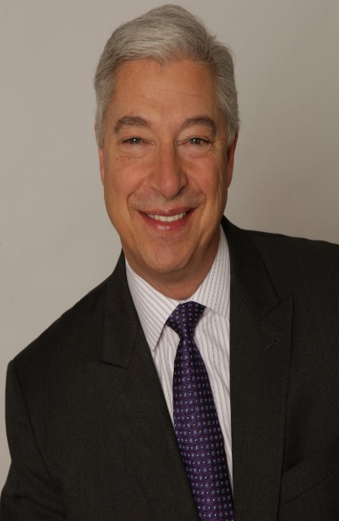

Founder and Chief Executive of Real Hospitality Group, (RHG) last year's 15th ranked hotel operating company in the United States. With properties located in 19 states, RHG has expanded from a start-up company to one of the most prominent hotel operators in only 9 years. RHG's leadership is represented on the board of directors of the American Hotel and Lodging Association, NYC & Company, Marriott and Hilton franchise advisory councils and several state lodging associations where we have presence. Real Hospitality Group's "Real Cares" division participates on a leadership level in organizations including, but not limited to: ECPAT, Feeding America and the National Cancer Institute. Several of RHG's team members have been nominated for their state's, as well as the AHLA's "Stars of the Industry" awards. RHG has also been awarded with "New Hotel Opening of the Year" and "Renovation of the Year" from Marriott International last year alone.
At Real, we believe that the industry is perfectly positioned to provide jobs to opportunity youth and adults who want a growing career. To that end, RHG prioritizes it's training and Promote from Within programs and serves as adjunct faculty, guest speakers and advisory board members to institutions that include the Florida International University, Farleigh Dickenson, The University of West Virginia and Central Connecticut University Schools of Hospitality Management.

CARRIE LEISHMAN DELAWARE RESTAURANT ASSOCIATION

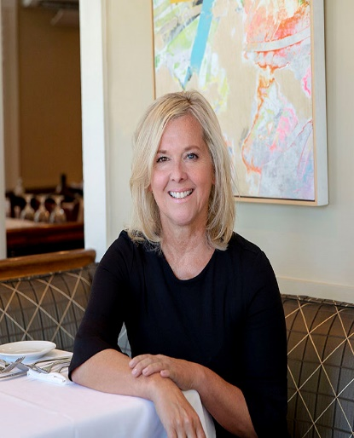
Carrie Leishman is the President & CEO of the Delaware Restaurant Association (DRA) and its philanthropic arm—The Delaware Restaurant Association Educational Foundation (DRAEF). 2020 marked Carrie’s 20th year as President & CEO of the DRA, the state trade association dedicated to promoting, educating and advocating for the Delaware’s foodservice industry, which represents close to 2,000 restaurants in the state.
Carrie grew up in upstate New York and graduated from the Newhouse School of Public Communications at Syracuse University. After spending 10 years with the Maryland Restaurant Association, she became the President of the Delaware Restaurant Association. She is credited with building and strengthening the DRA—taking a handful of members and a minuscule yearly budget and turning it into one of the most influential business organization in the state. Carrie is often described as a passionate and fearless advocate for the industry, and has been featured in Delaware Today Magazine where she was recognized as an influential Woman in Business as well as The Delaware Business Times “25 People to Watch” and most recently named a “Local Food Hero” in Edible Delmarva Magazine.
Carrie was recognized by The White House In late 2018 and attended the signing of President Trump’s landmark, bipartisan legislation to combat substance abuse and addiction. Carrie represented the nation’s restaurants for her organization’s development of the first, industry training for substance abuse awareness and prevention and most recently a new nationwide online certification course in collaboration with The University of Delaware for hospitality human resources.
In 2014 Carrie expanded the DRA by forming the Delaware Restaurant Association Educational Foundation (DRAEF). This non-profit entity of the DRA focuses on training, education and workforce development for students, underserved populations, and those already in the foodservice industry. The DRAEF’s premier culinary and management program is the ProStart Program, which currently reaches over 3,000 students in 18 high schools throughout Delaware as well as in Delaware’s prison system. The Foundation expanded by developing one of the first in the nation’s cook apprenticeship programs and is now leading in the state’s effort to expand youth apprenticeship. Carrie has spent time mentoring high school youth in Delaware’s foster care system, is an avid writer and national speaker and is an adjunct professor in the University of Delaware’s Hotel, Restaurant & Institutional Management Program.

MARSHALL WESTON RESTAURANT ASSOCIATION of MARYLAND

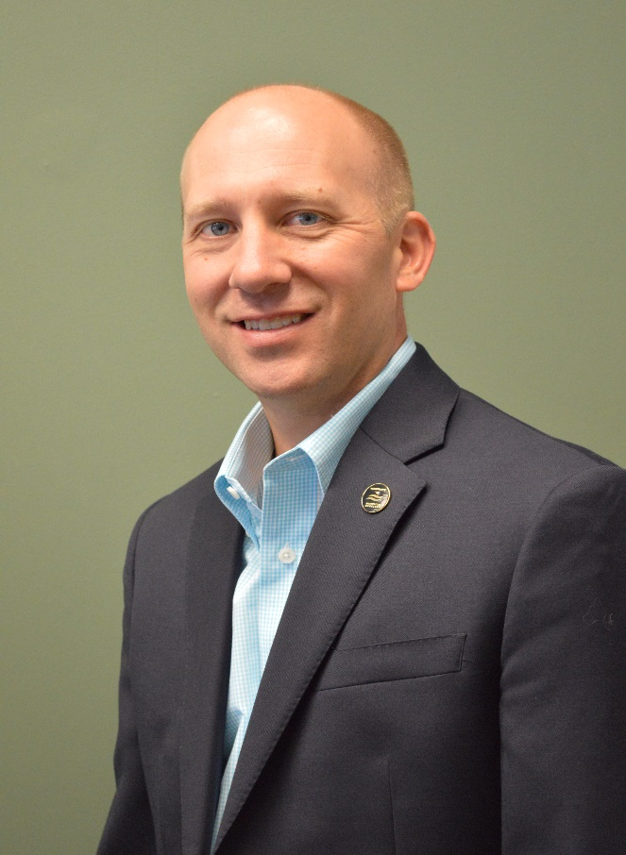

Marshall Weston has held a number of senior management positions in non-profit associations and the foodservice industry over the past 25 years. He is currently the President and CEO of the Restaurant Association of Maryland (RAM), a statewide trade association of over 2,000 members that is dedicated to promoting, protecting, and improving the foodservice and hospitality industry in Maryland.

Weston’s knowledge and expertise comes from over ten years of restaurant management experience along with a degree in Public Policy from Penn State University that included working as a Legislative Fellow in the Pennsylvania House of Representatives. He prides himself in keeping a team of employees, engaged association members and industry partners to ensure that RAM is the most trusted source for restaurant advocacy, regulatory compliance information, foodservice employee training and restaurant focused vendors.

